**Increment-3 documentation**

**Objectives:**

We are developing an android application with different features in it. We have two different tabs in our application:

1. Shopping tab
2. Journey/appointment tab
3. About tab

Once the user logins successfully into our app, he gets directed to a page with the above mentioned tabs. Using the *Shopping tab* the user can create a reminder for the list of Shopping items and the date, Using the *Journey tab* user can create a reminder for the total journey along with the halts if any with a specified times. In the *About tab*, we provide complete information about the app for the first time user.

The overall goal of the app is to provide an alert for their day to day activities.

We are already done with the login page and shopping tab, in this increment we developed the journey tab.

**Import Existing Services/API:**

1. **Name:** Google Maps API.

**Description:** This API is used both in journey and shopping tab, in the shopping tab we use this to find the stores requested and to locate them.

In the journey tab we use this to find the route from source to destination.

**URL:** <https://developers.google.com/maps/documentation/javascript/tutorial>

1. **Name:** Walmart API

**Description:** this API is used to find the items available in the Walmart store for shopping tab.

**URL:** <https://developer.walmartlabs.com/docs>

**Detailed design of services:**

***Service description:***

In this application we are going to develop a reminder application which can be used for multiple purposes. We have 2 types of accounts:

1. Parent account
2. Child account

The use of this accounts is that the parents can monitor the activities of the child if registered.

In the login page we have options to signup (if he is a first time user), login (if he is an existing user) and forgot password option (if he forgets his password).

Once the user successfully logs in to our application, he has 3 tabs:

1. Shopping tab
2. Journey tab
3. About tab

**Shopping tab:**

This is implemented in increment-2.

In the shopping tab, the user can provide details about the list of items and the date and time on which he wants to buy them. He gets a reminder at the specified time. He also has the features to locate the store and also to search items in that store.

**Journey tab:**

In the Journey tab, the user can add his journey details: *source* and *destination* with respective times and dates. Once the journey is added, he can update it or get its details or delete the journey.

To *add halts* to the journey, click on update and then click add halts button, he will be directed to a new page to provide details about the halts which gets reflected in our journey. He can add any number of halts he wants.

Once he created a journey, he should click on *start* button to start the application or *exit button* to stop the application.

**Scrum do screenshots:**

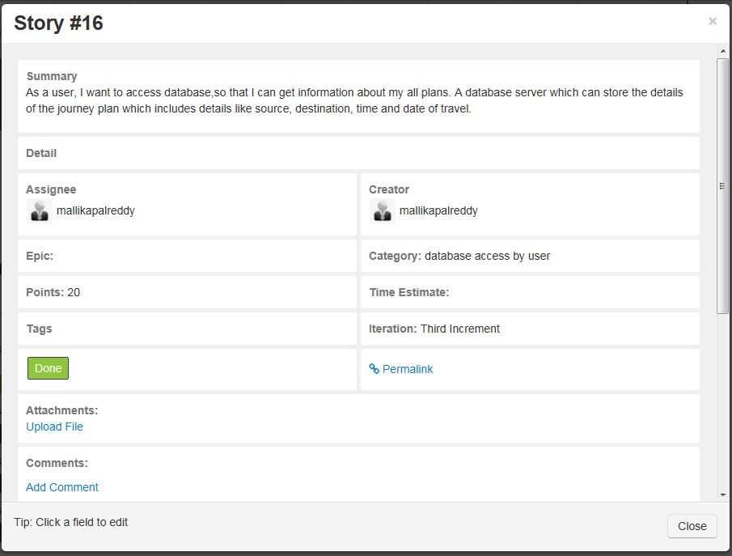

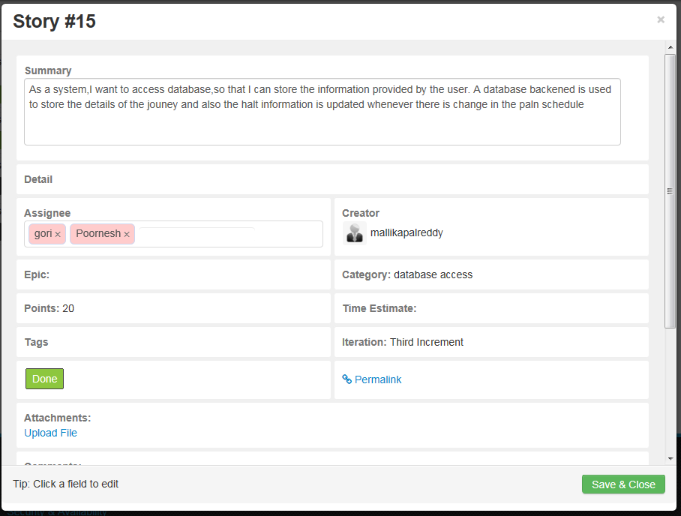

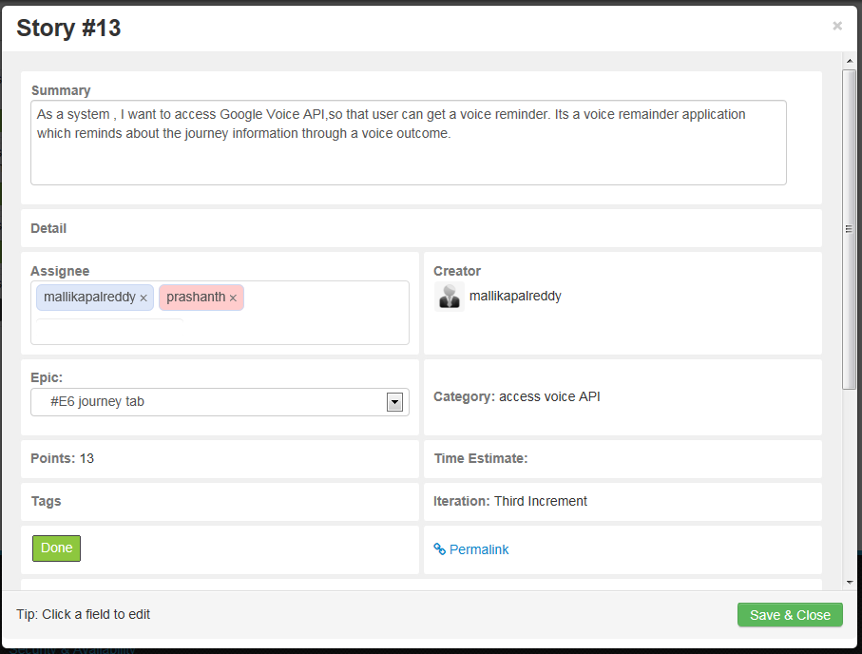

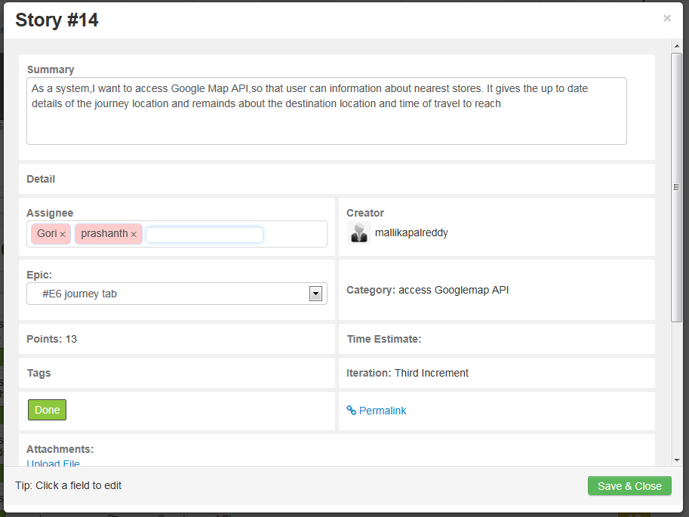

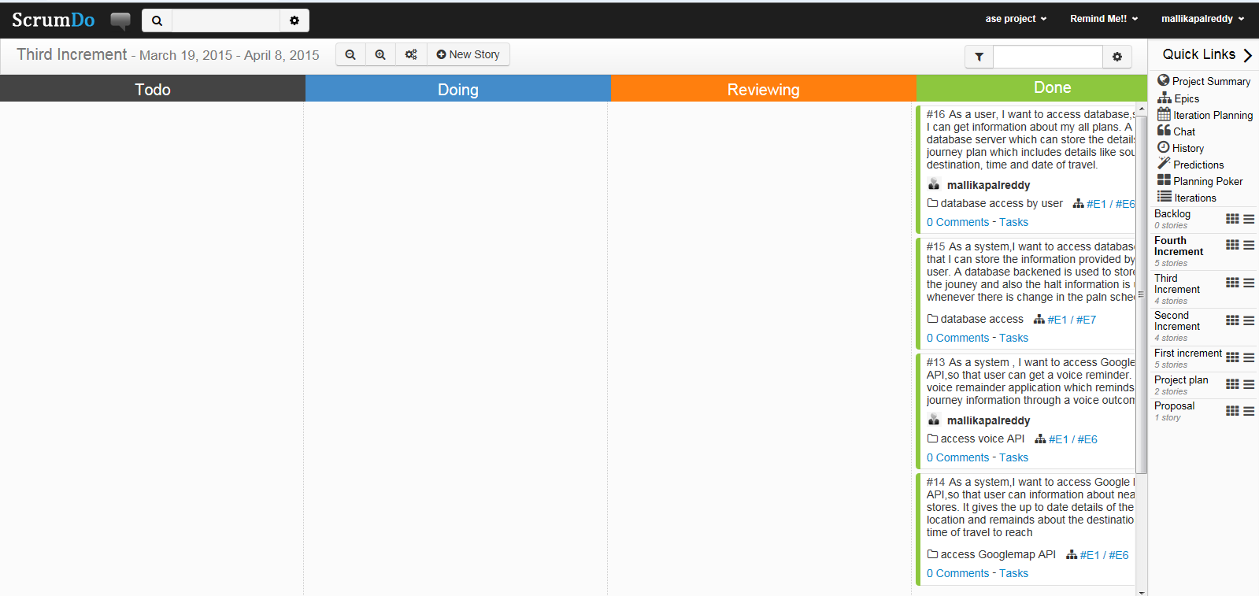

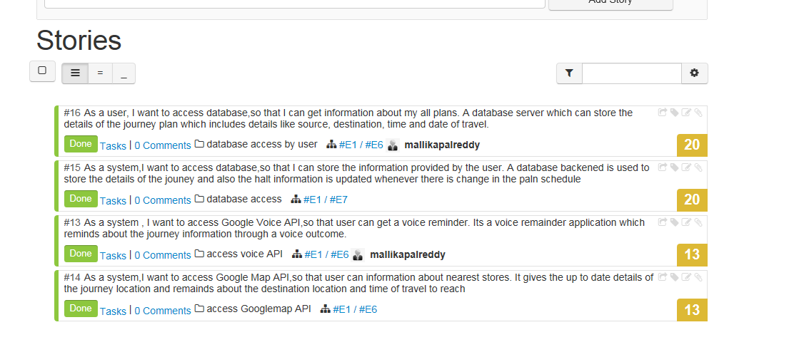

**Architecture:**

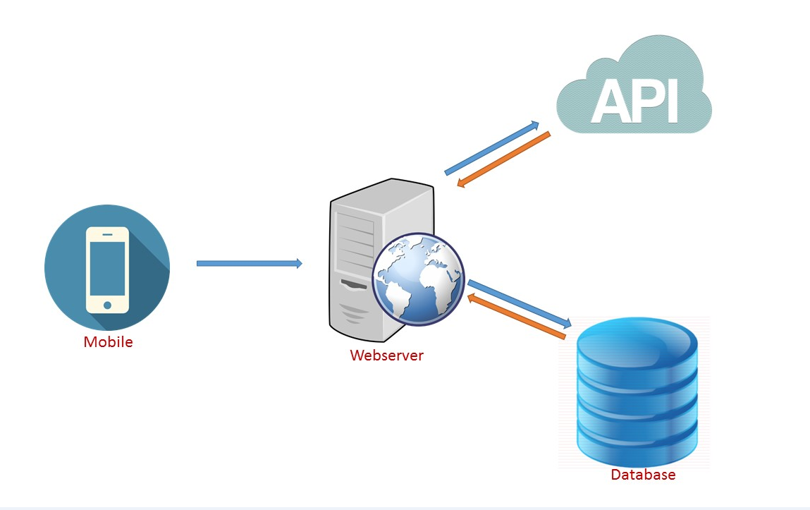

**Class Diagrams:**

**Class Diagrams:**

**Login Page**

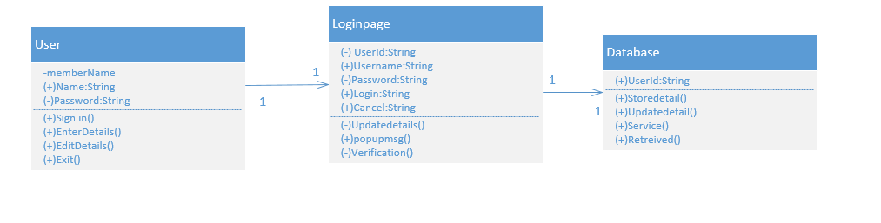

**Registration Page**



**Shopping tab:**

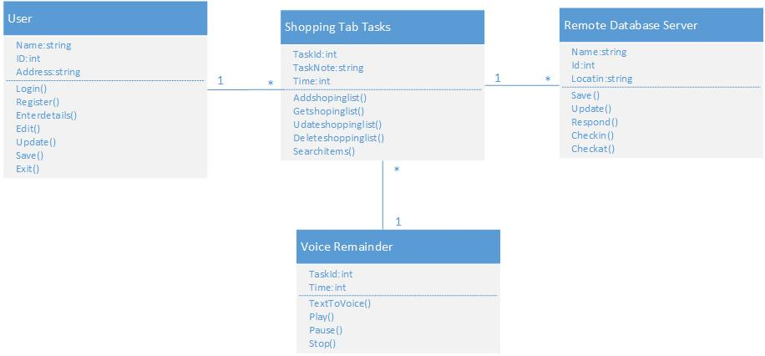

**Journey tab**

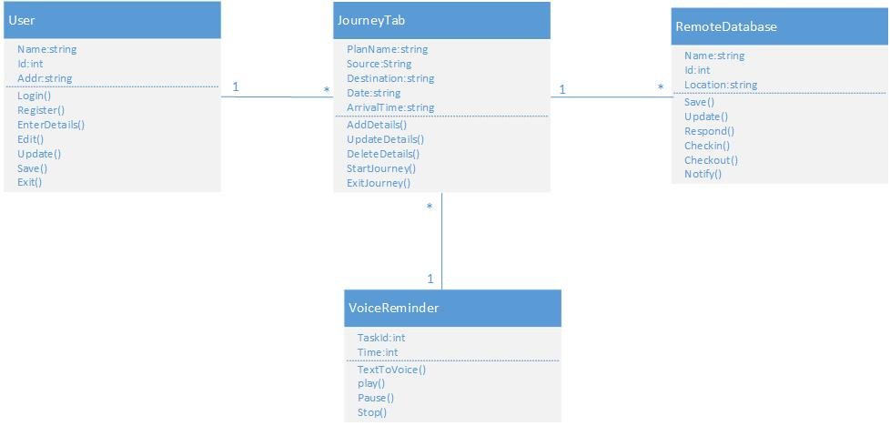

**Sequence Diagram:**

**Login Page**



**Registration Page**



**Shopping tab**

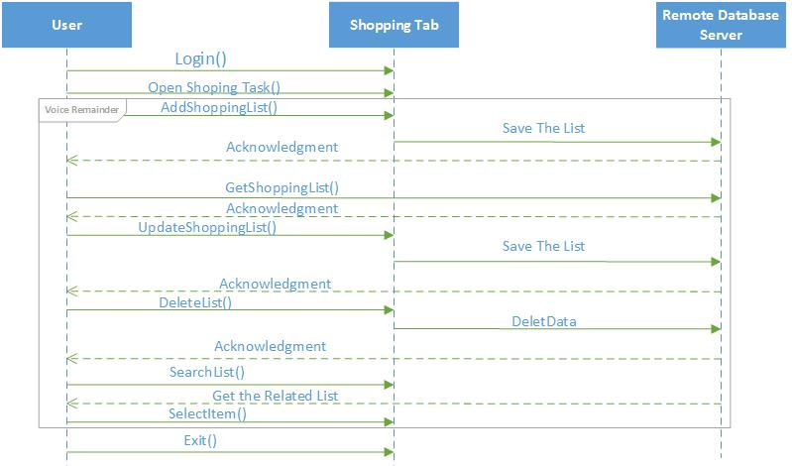

**Journey tab :**

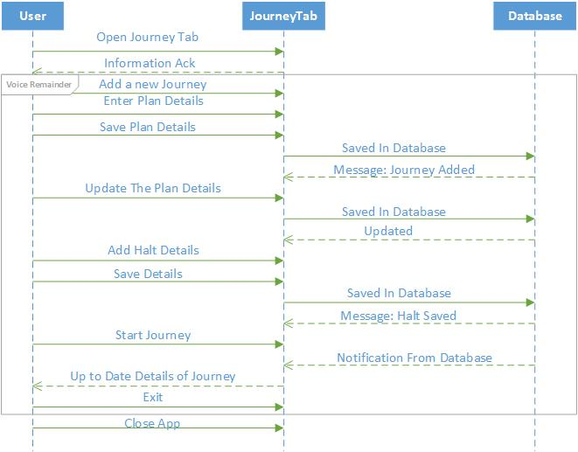

**Design of mobile client interface:**

**Journey interface:**

1. Adding a journey

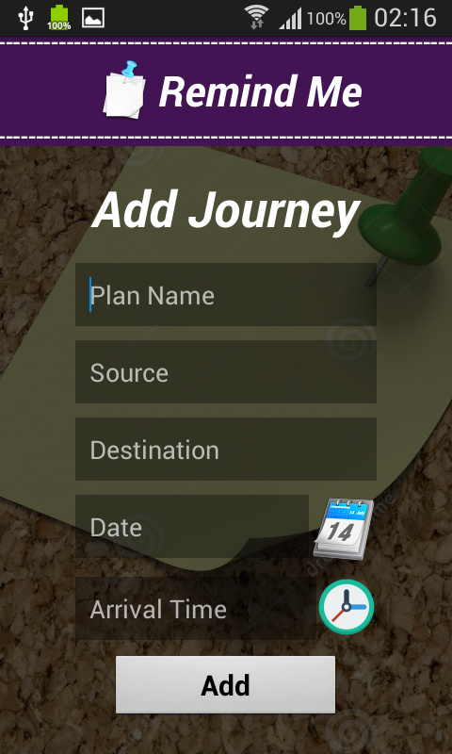

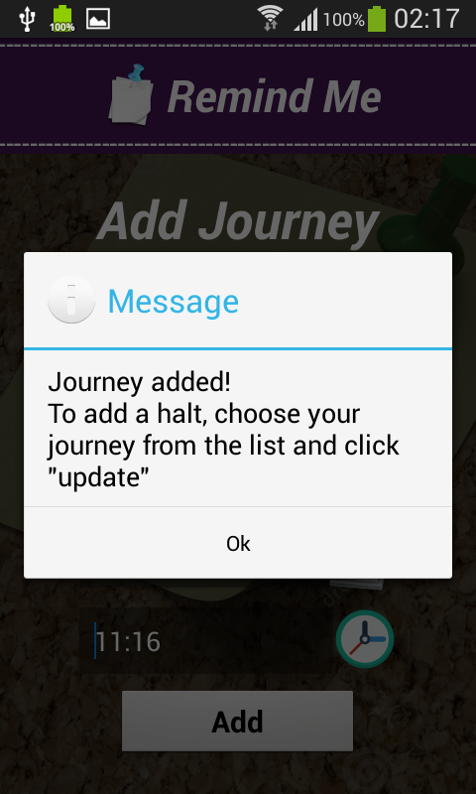

Displaying lists of journeys added.

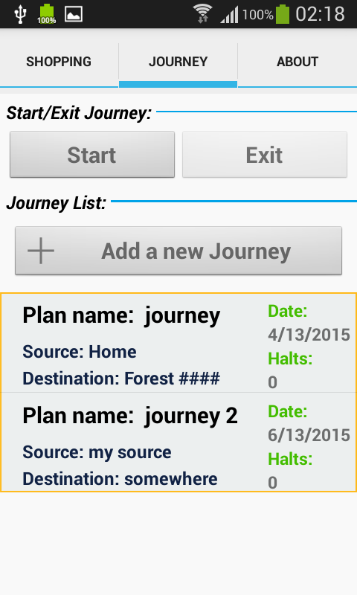

On click of journey added, here we have 3 options to select

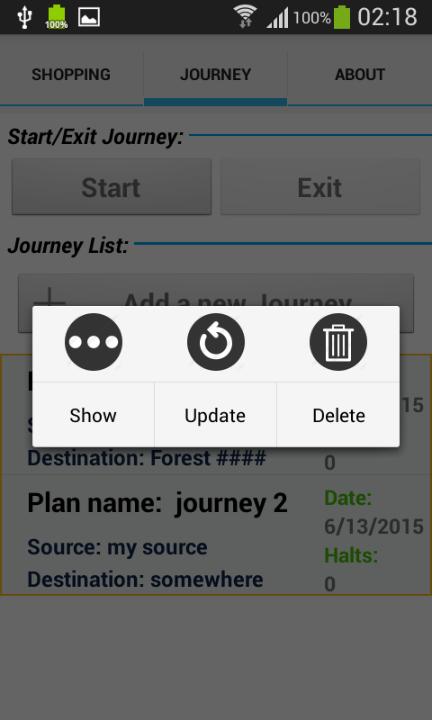

To update the journey, click on update. The below page will be displayed.

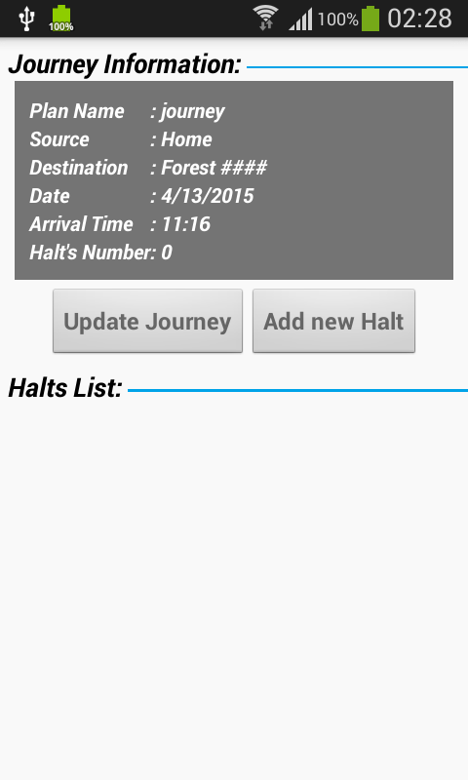

Here, we have 2 options:

1. To update the journey
2. To add halts to the journey

If we select update journey the below page appears,

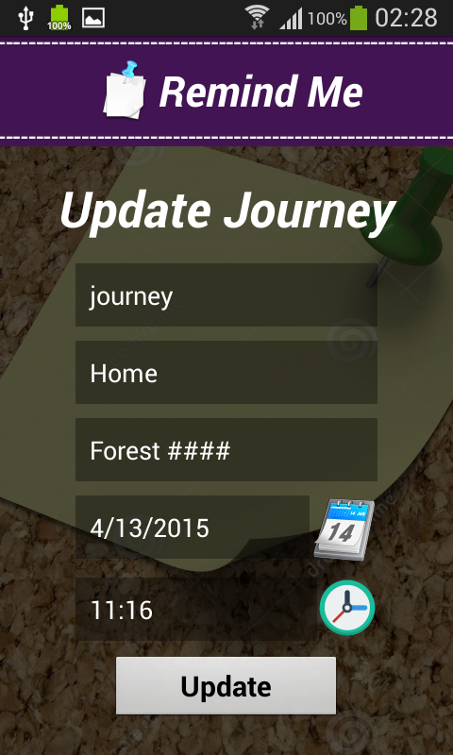

This page displays , when we want to set the time.

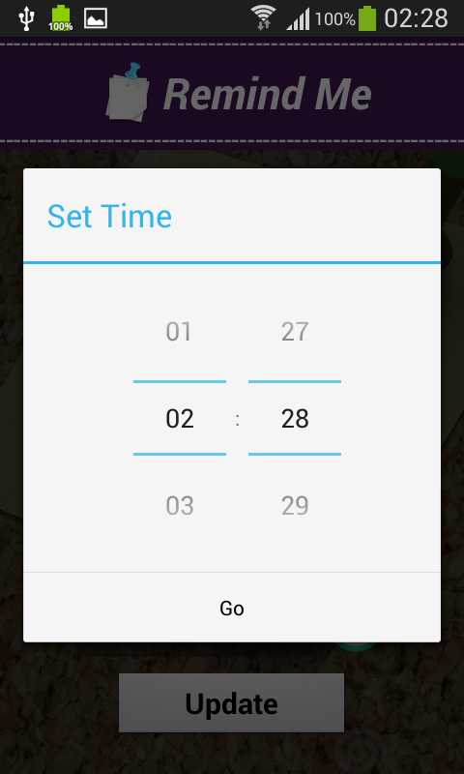

This page appears after successfully updating journey.

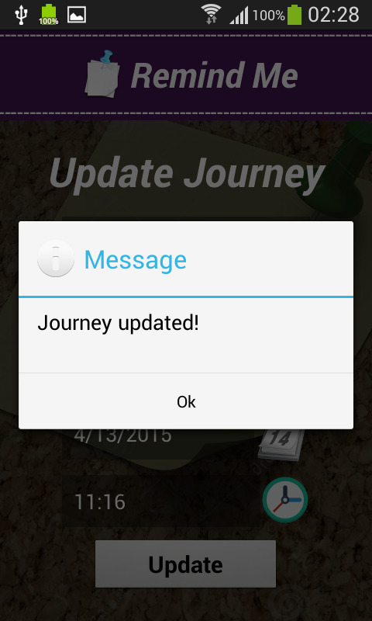

If we select option2: add halts, the below page appears

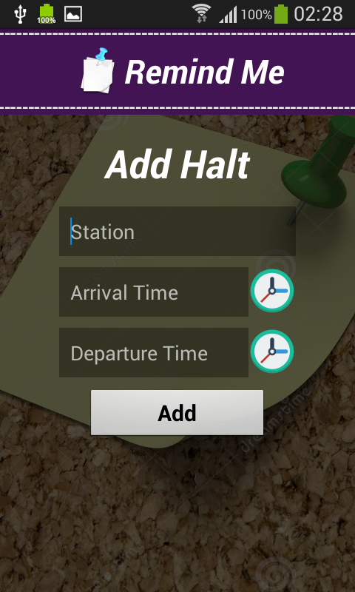

Message after successfully adding halt

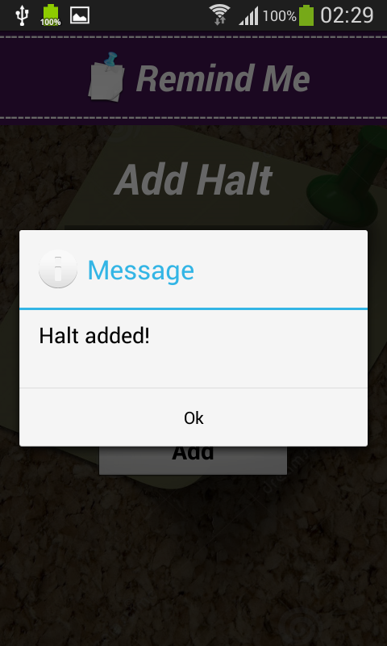

Once we are done with adding the journey, we have to click start button to start the application

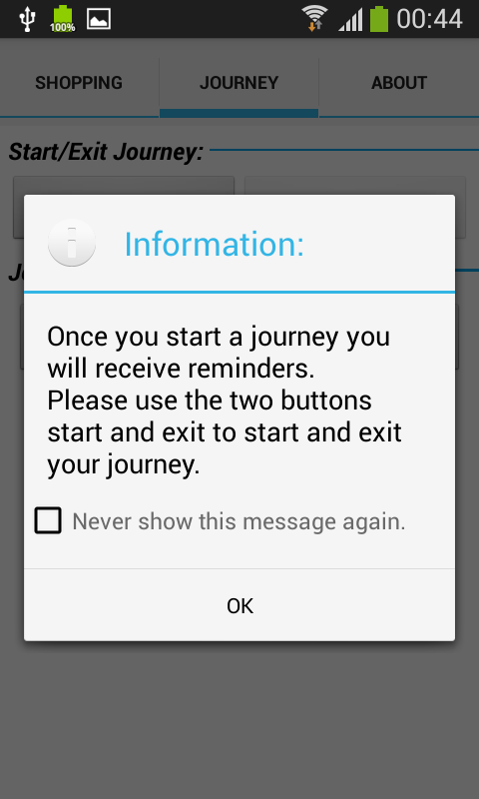

**Implementation of mobile client interface:**

**Journey tab:**

**Step 1:**  When we select journey option from the journey tab the following window opens.



**Step 2:**

Selecting “Add a new Journey” option from the above dialogue box the following information dialogue box appears.

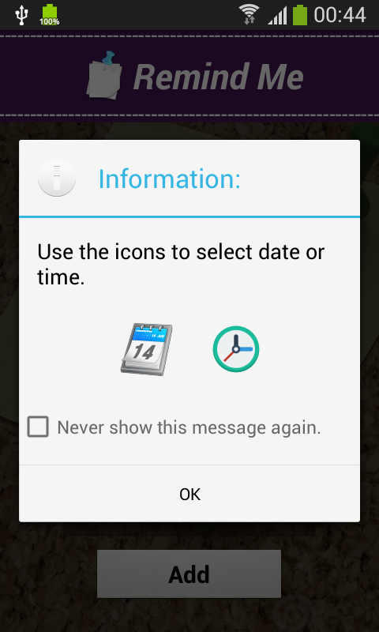

Step 3:

The details of the journey should be given in the corresponding tabs present above and if the details provided are inappropriate the following windows appear.

If the details are corrected by providing the required details the next window is appeared.

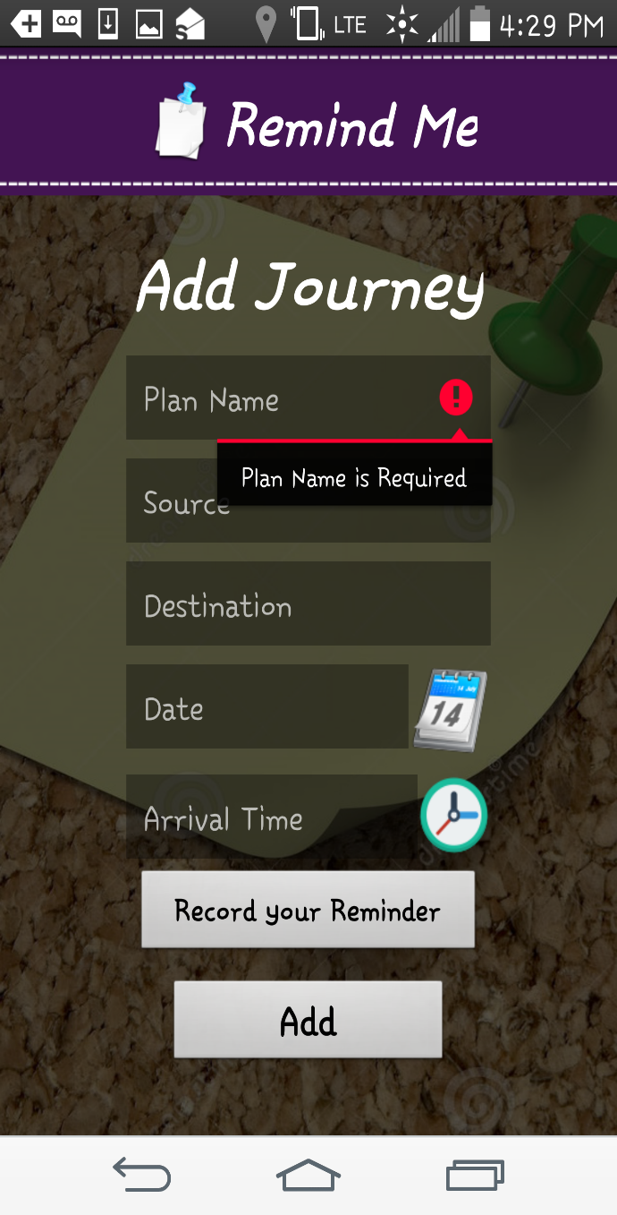

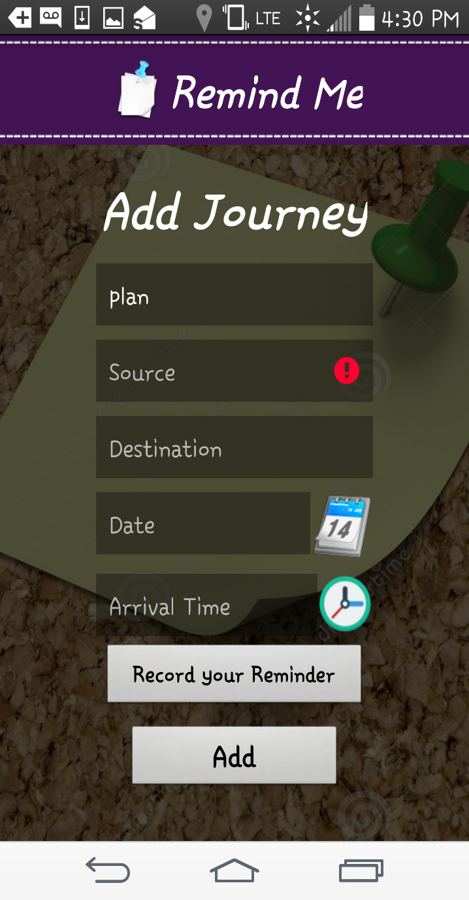

Here in the above adjacent window since source address is not provided an alert message is displayed for alerting the user to provide source address.

**Step 4:**

If the source address is provided and if destination address is not provided, in the next step an alert message for the user is displayed seeking for the destination address.

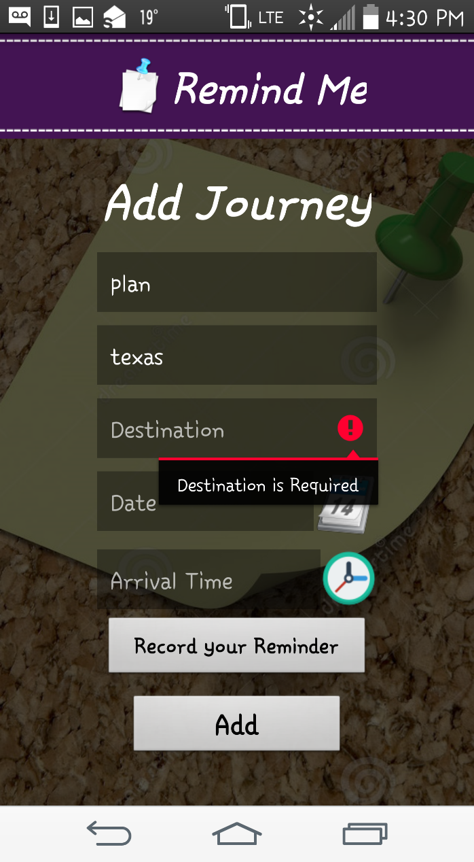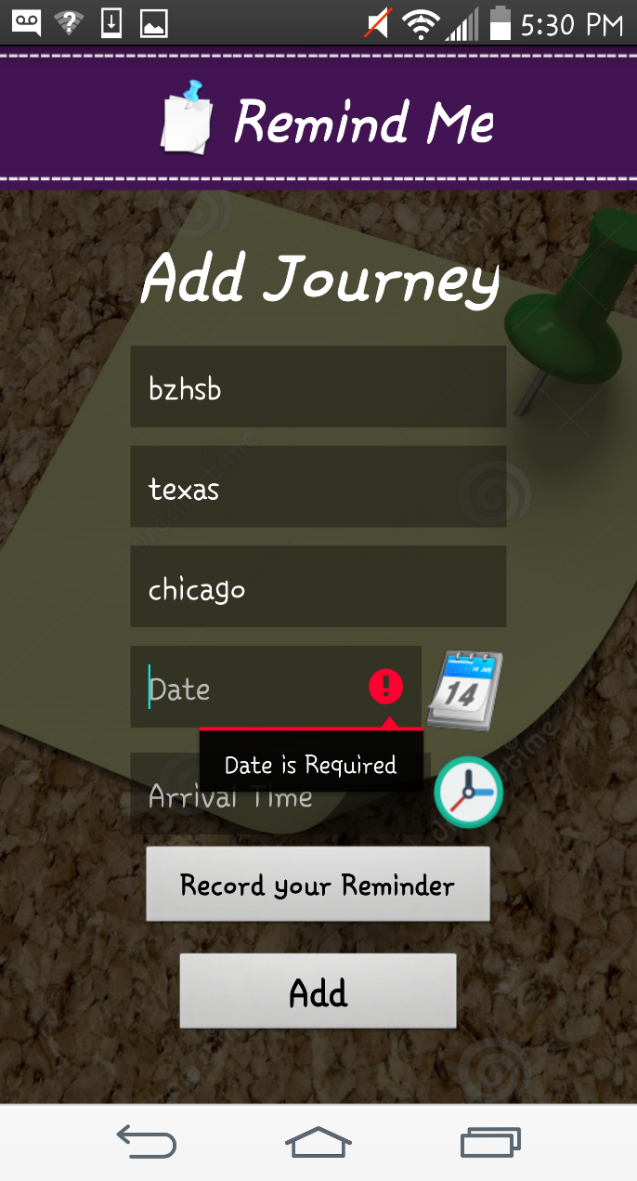

Similar an alert message is displayed for the date, time of arrival if the details are not provided by the user prior to the adding of the reminder.

**Step 5:**

The user can select the date from the date window that pops up when the calendar is selected.

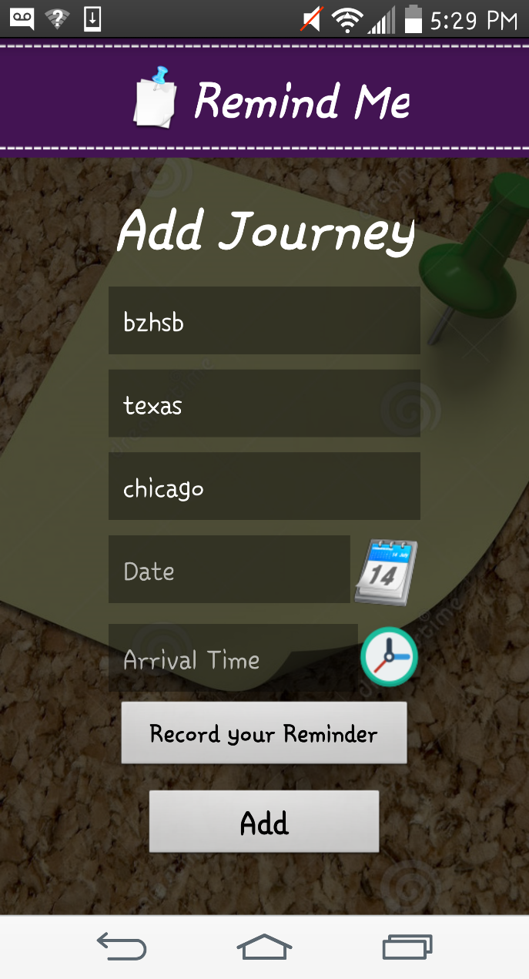

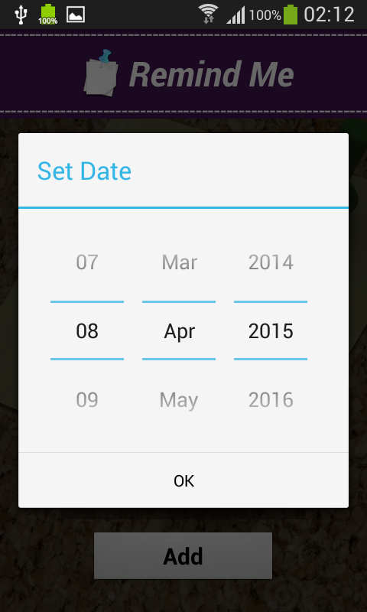

**Step 6:**

The user can select the time from the following popup message and once all the details are provided the journey will be added to the list of remainders and the window appears as shown here.



**Step 7:**

To add a new halt in the journey user can select add new halt tab and give the details of the halting place and time and update his record of journey from the following window.

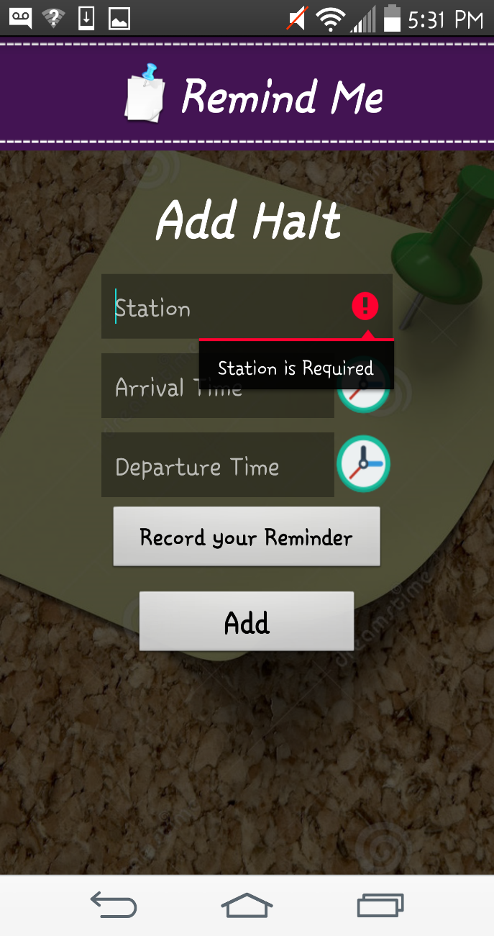

Similar to the alert messages that are provided in the above tabs here also if the required details are not provided an alert message is displayed to the user seeking information about that details.

**Step 8:**

Though all the details are provided by the user and if user did not provided/recorded the voice reminder a pop up alert is displayed as below. If the user wants to add a voice alert by recording his/her own voice reminder, user can do as follows that is shown in the adjacent window.

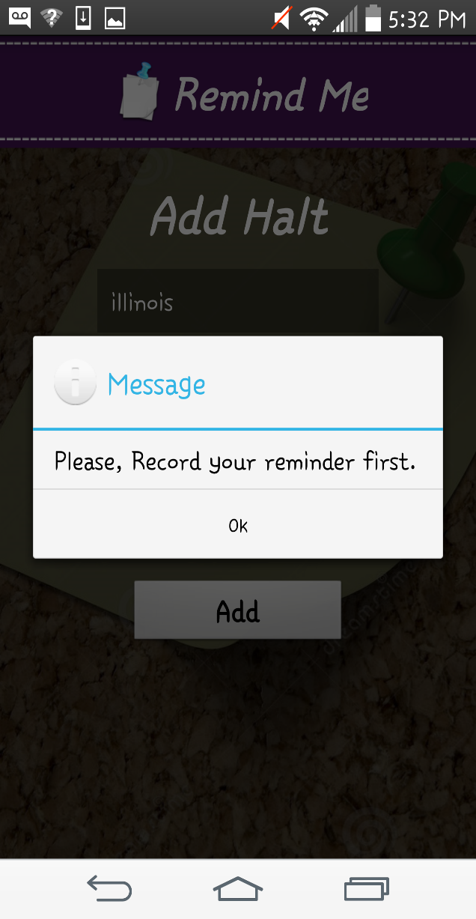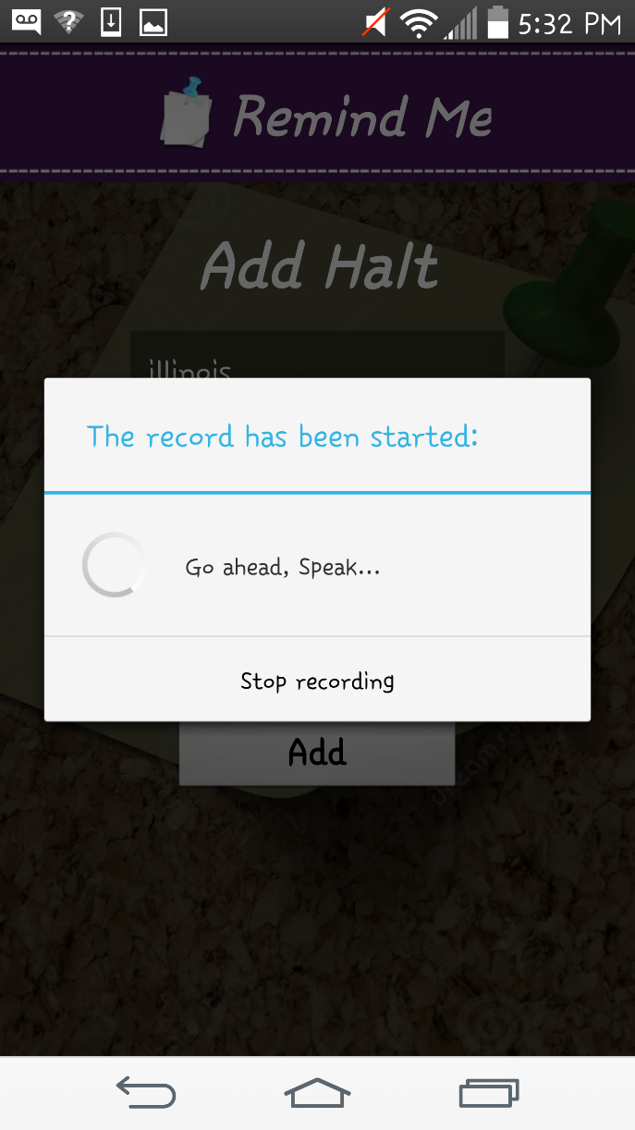

**Step 9:**

After all the details are provided by the user for the halt and also a voice reminder the halt will be successfully added.



**Step 10:**

If the user want to update the Journey details, it can be done as follows by selecting the options show/update/delete. If the user selects the Update option the adjacent window opens.





**Step 11:**

Once the journey is updated the following window appears. Similarly the halt can also be updated by selecting the update option which is shown in the above window. When the halt is also updated the following window appears confirming that the halt is updated.

 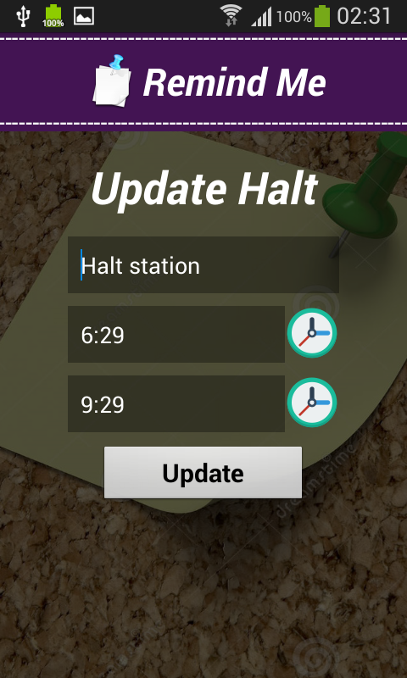

.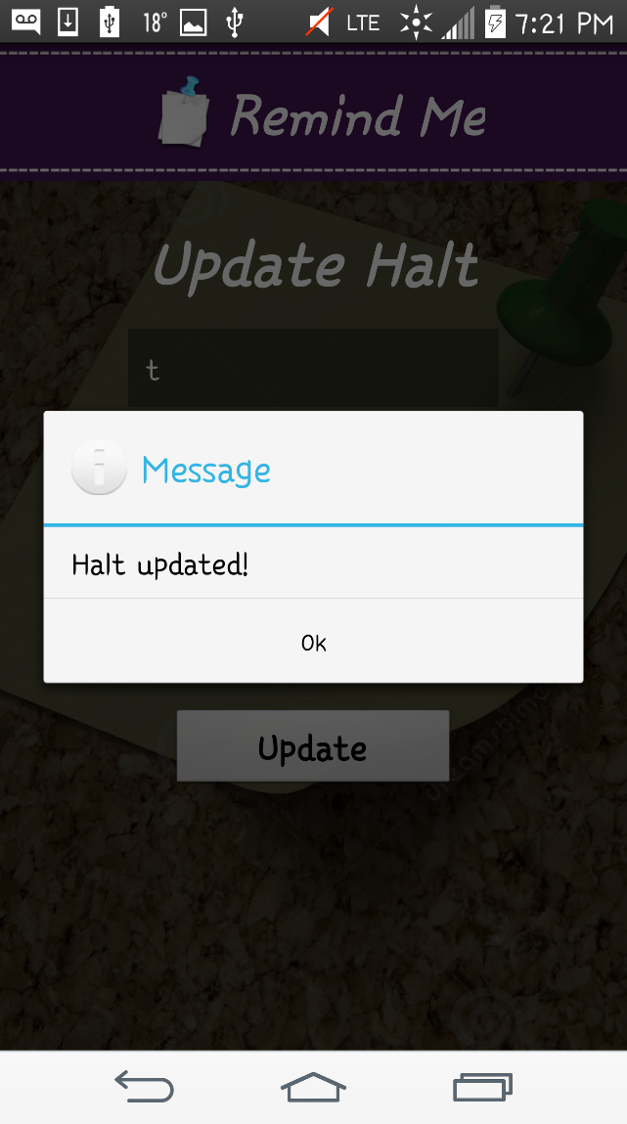 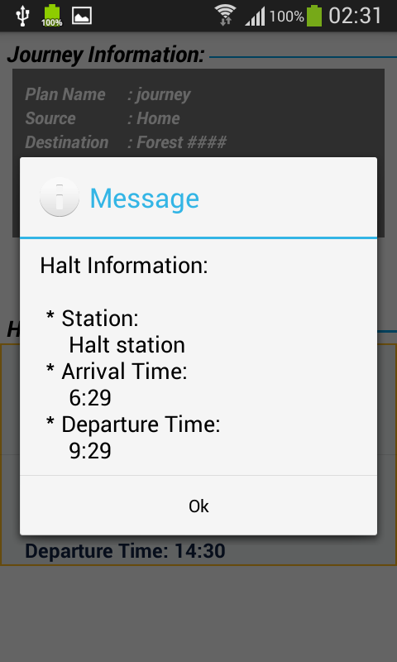

When the halt is updated a notification message on the window as show above.

It contains the arrival and departure time and station name etc.

**Step 12:**

If the user want to see any of the journey/ halt details it can be seen in the following windows by selecting the show button that is popped up when user select the respective journey.



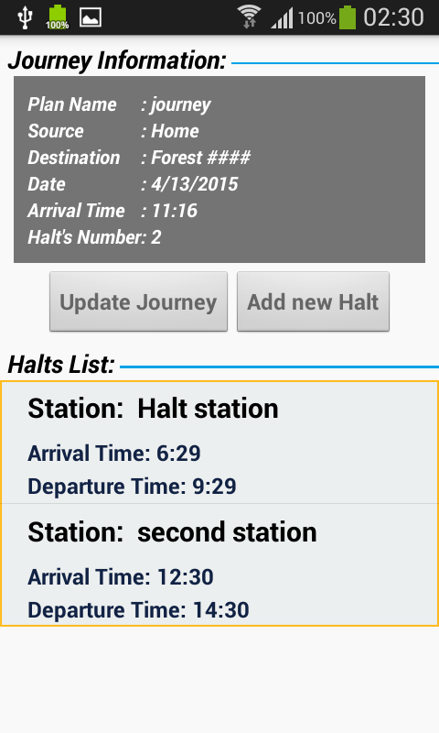

**Step 13:**

Similarly when the user wants to delete any of the journey / halt it can be done from the above shown popped up buttons. If the user deletes the journey / halt records and remainders the following confirmation dialogue boxes appears.

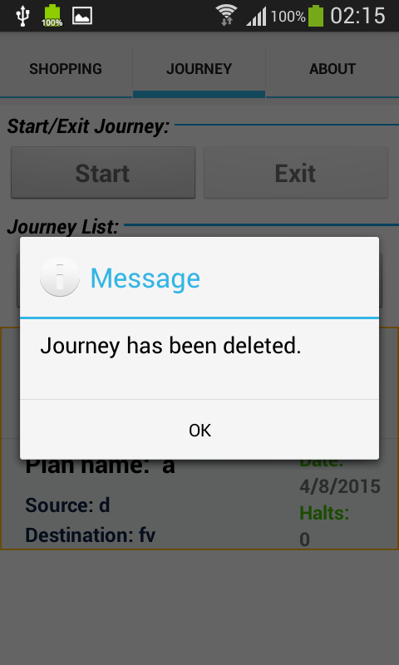 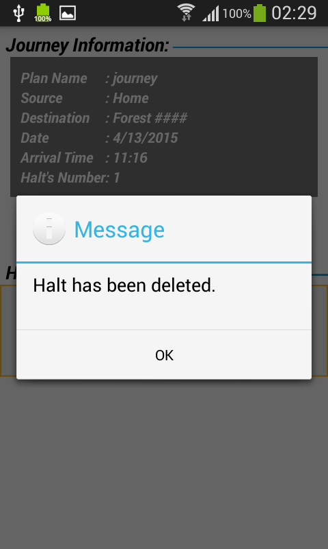

**Step 14:**

Once the user is ready and everything is done by providing the details the reminder is set and ready and the following window is displayed.

(Notification alert along with the voice reminder ) 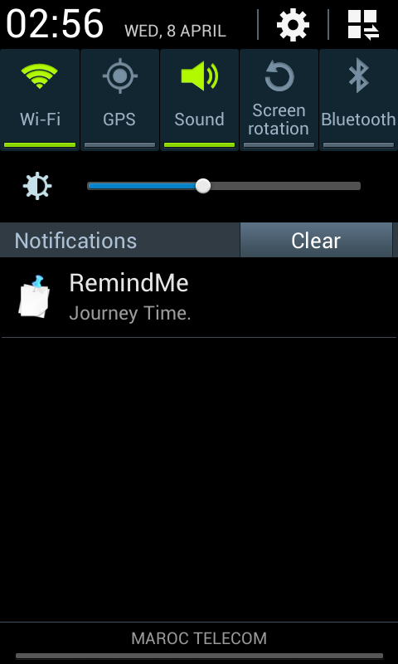

**Testing:**

Testing is done using Advanced Rest Client Services.

We are this testing as we have get, post methods and we get the reply instantly in json format.

**Journey services:**

1. Adding a new journey

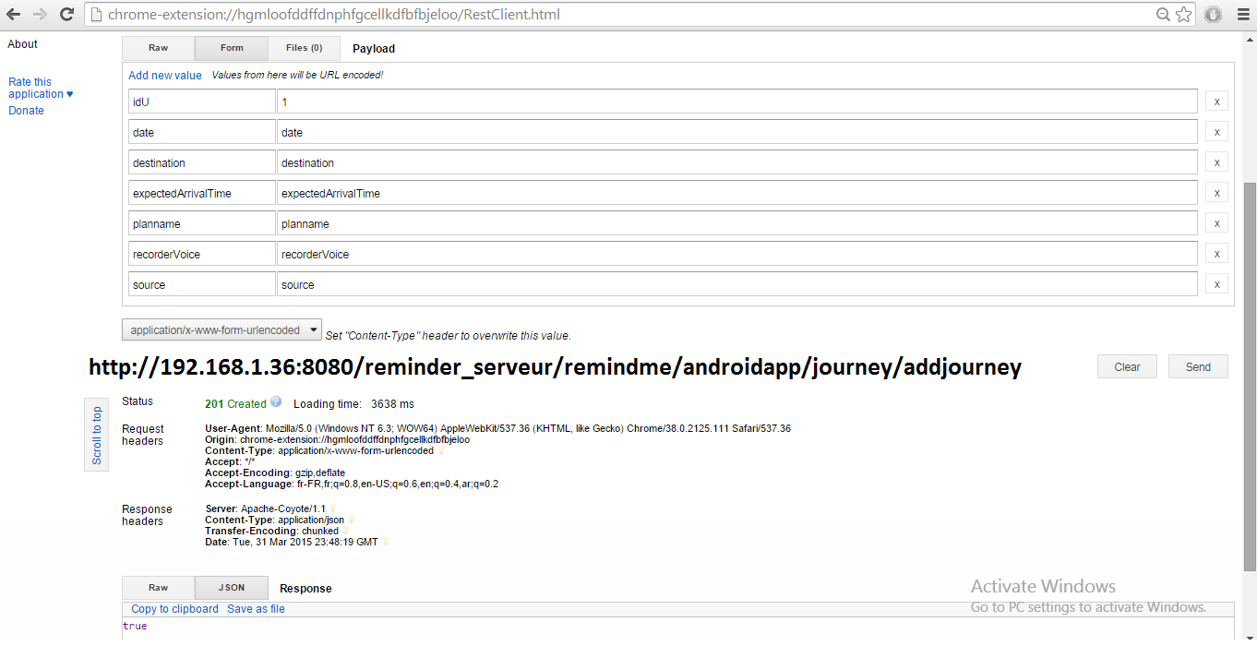

1. Deleting a journey: which is not successful as id mentioned doesn’t exist

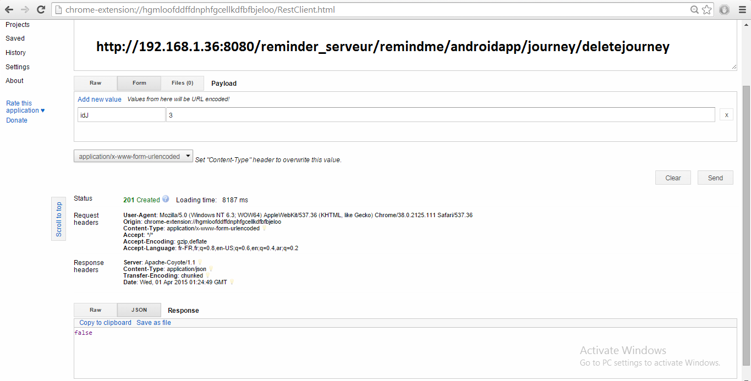

1. Deleting a journey: which is successful

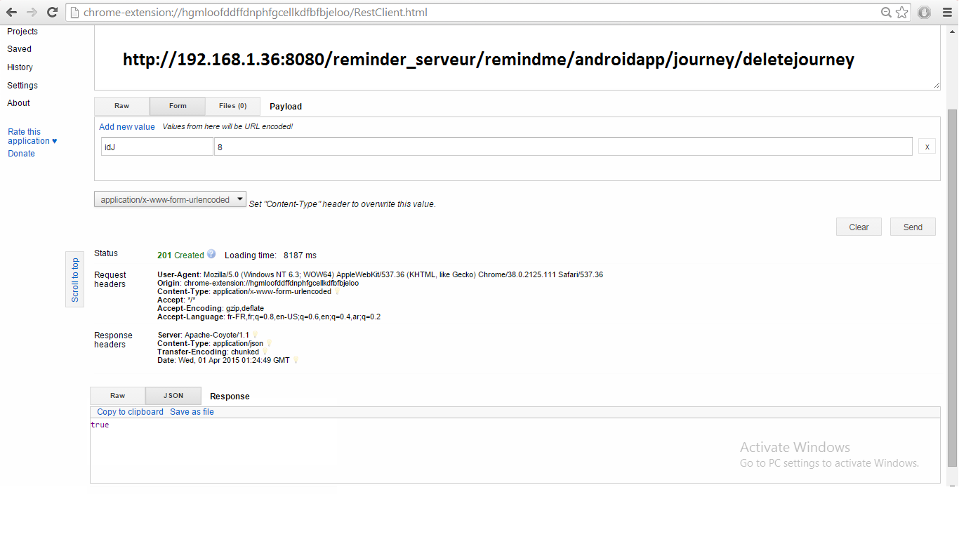

1. Getting a journey list with a particular id

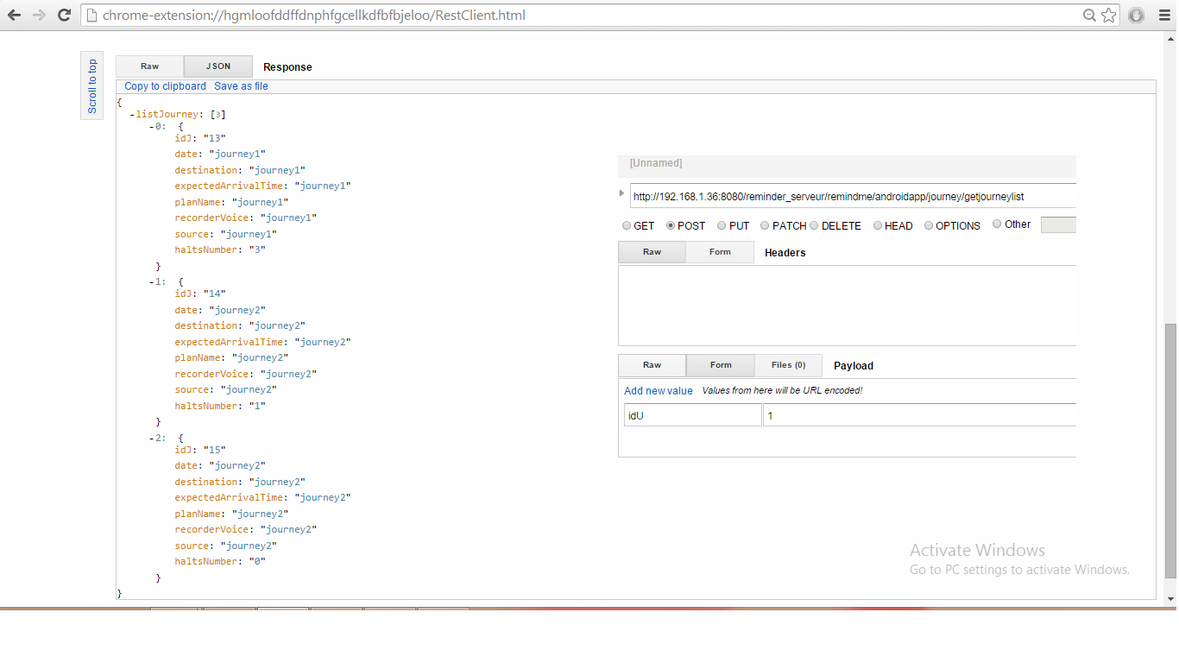

1. Getting a journey list of a particular id which doesn’t exist

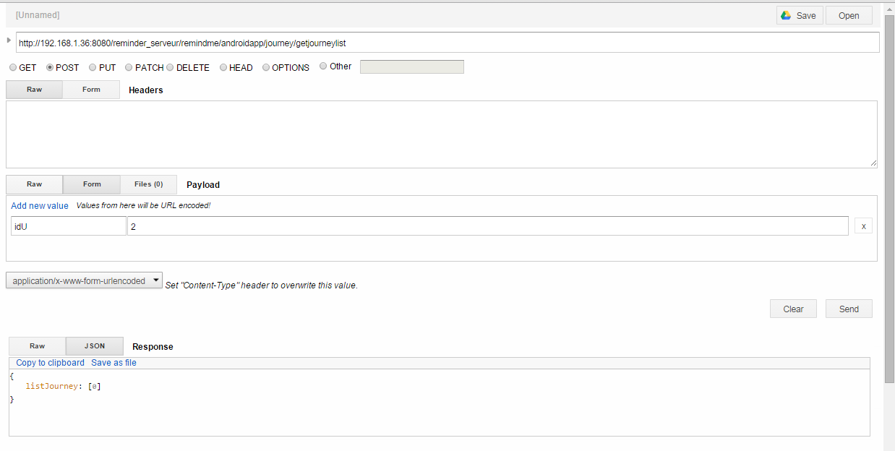

1. Updating a journey - which is not successful

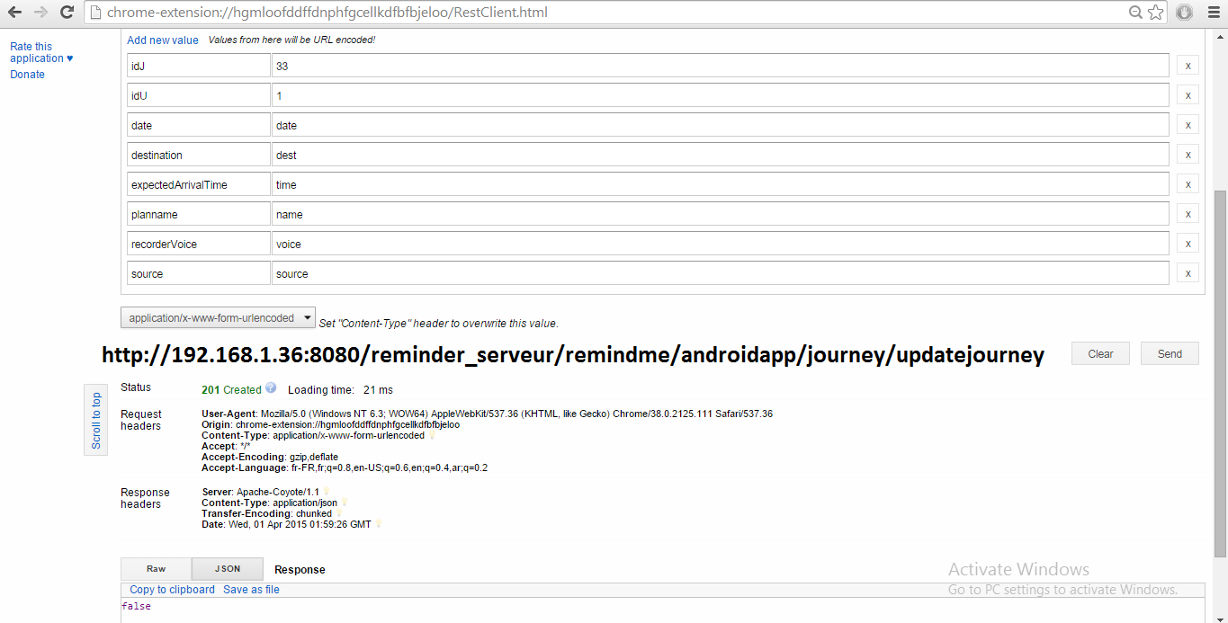

1. Updating a journey – which is successful

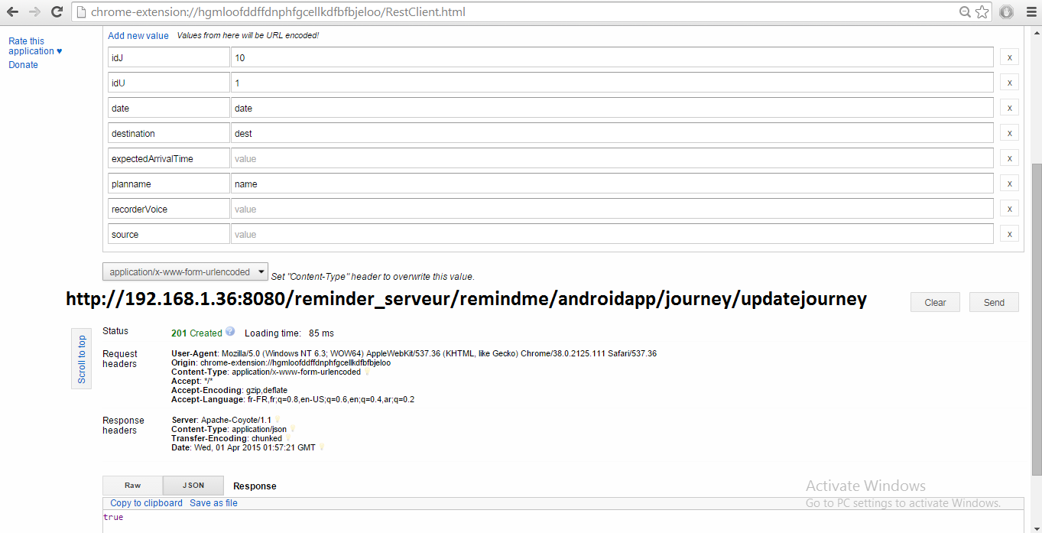

**Halt services:**

1. Adding a new halt

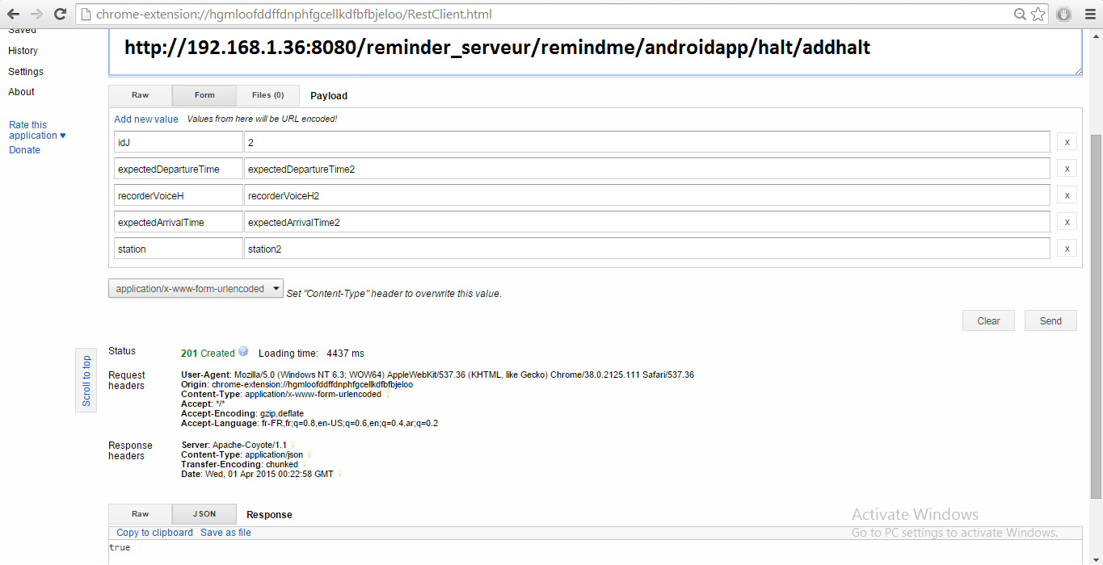

1. Deleting a halt – which is not succcessful

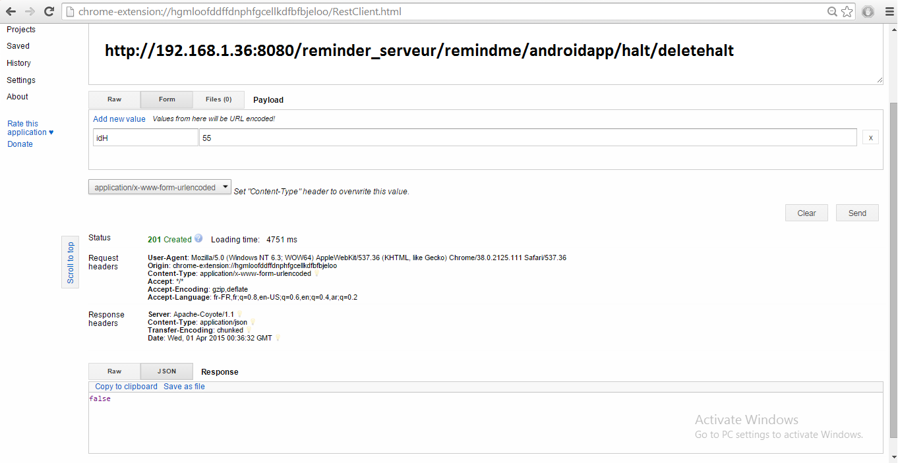

1. Deleting a halt – which is successful

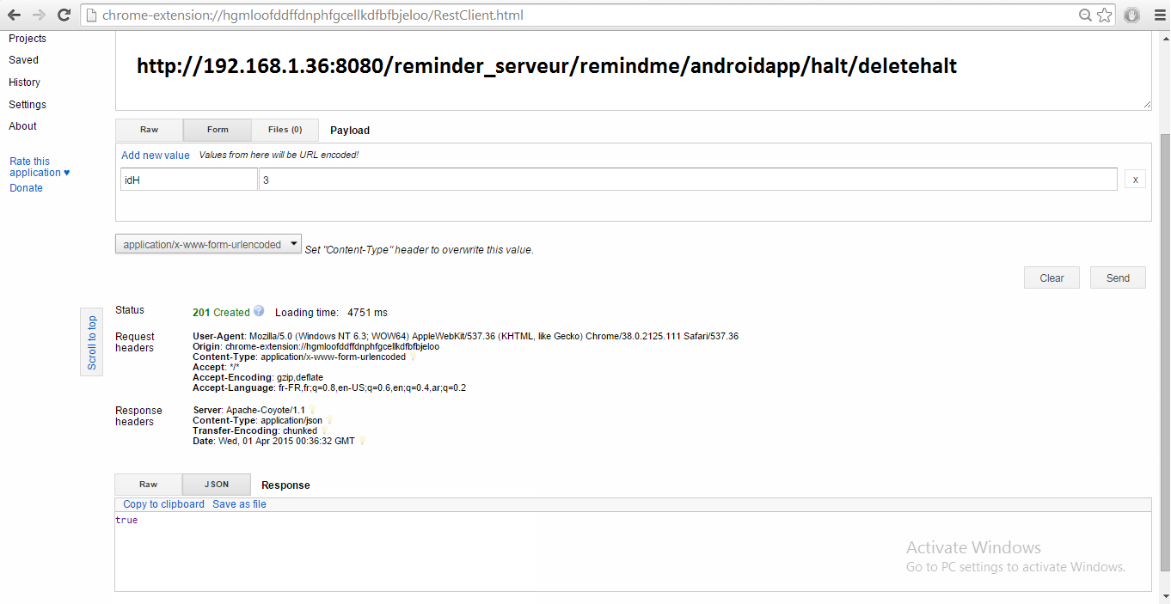

1. Displaying a halt list of a journey with only one halt.

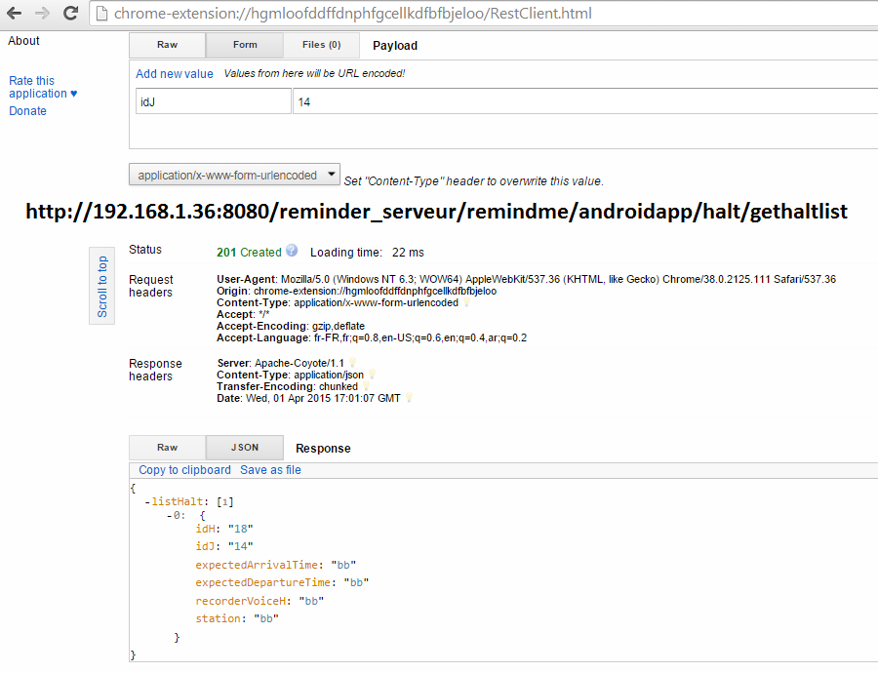

1. Getting a halt list of a journey with 3 halts

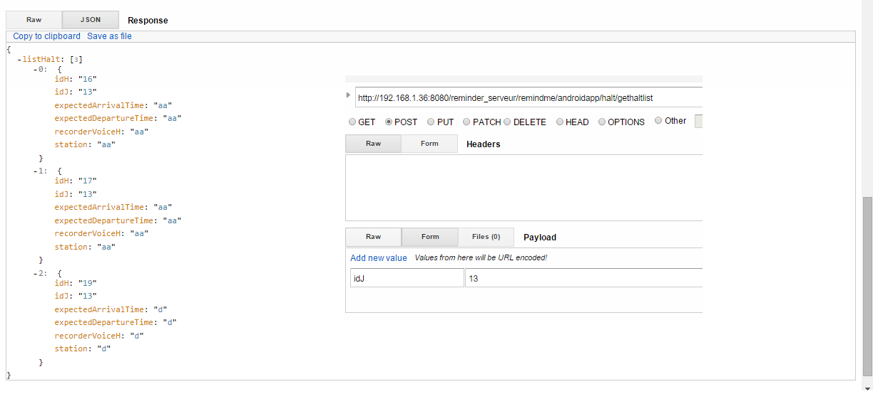

1. Displaying halt lists for an journey which doesn’t have any halt

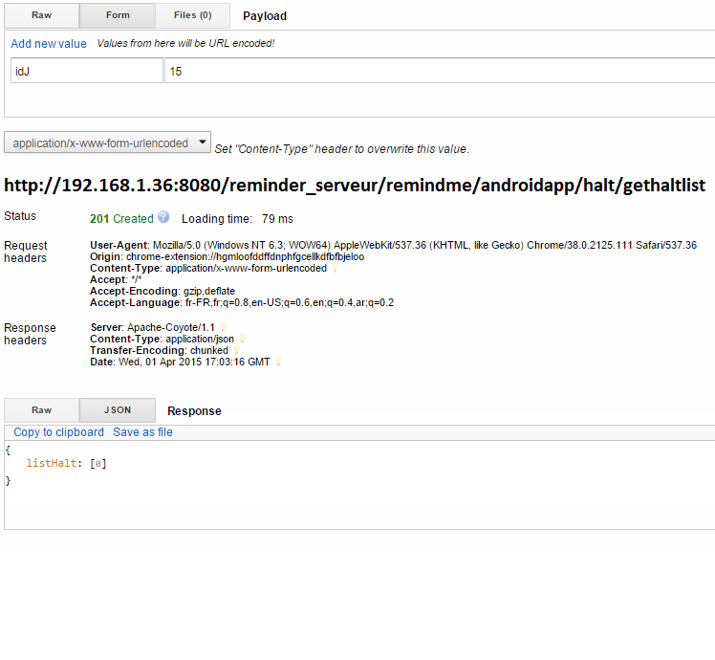

1. Updating a halt – which is not successful

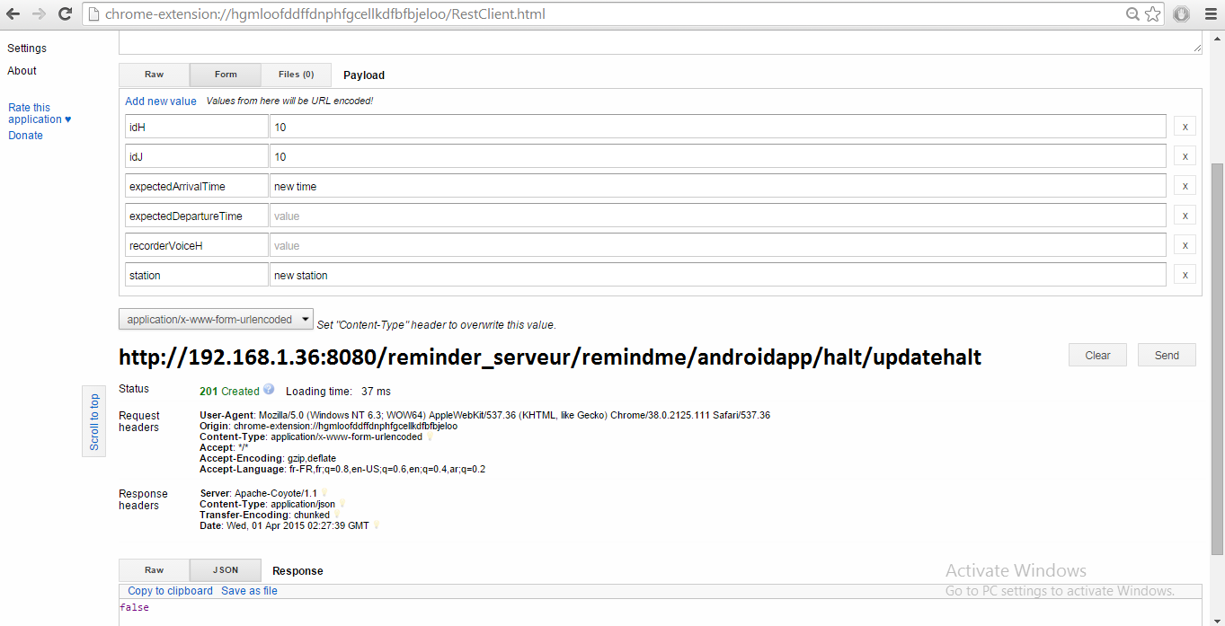

1. Updating a halt – which is not successful

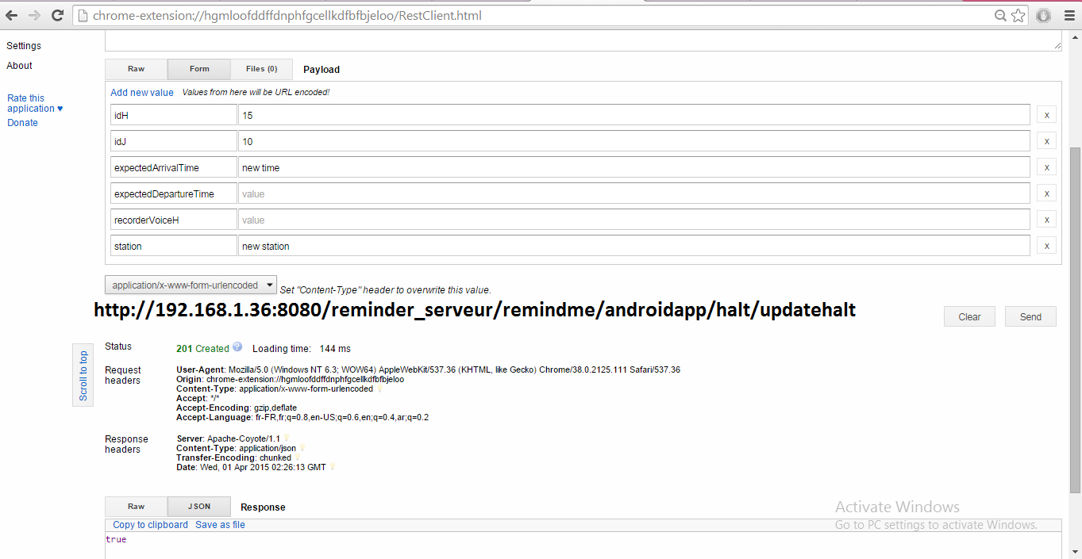

**PERFORMANCE TESTING USING DDMS TOOL:**

Dalvik Debug Monitor Server (DDMS) is a debugging tool in Android and it is having lot of features like thread and heap information on the device, log cat, process, location data spoofing, network traffic examining and more.

Here are certain features examined by DDMS Debugging tool.

1. **Examining the Thread information:**

For a selected process it examines the number of threads running for a selected process.

In this case for the process selected from the device tab “com.palreddy.remainder” it shows the information of all the threads for the process, their ids, and status of the threads, Utime and Stime for the threads. This shows the performance indication for each thread and the whole process.

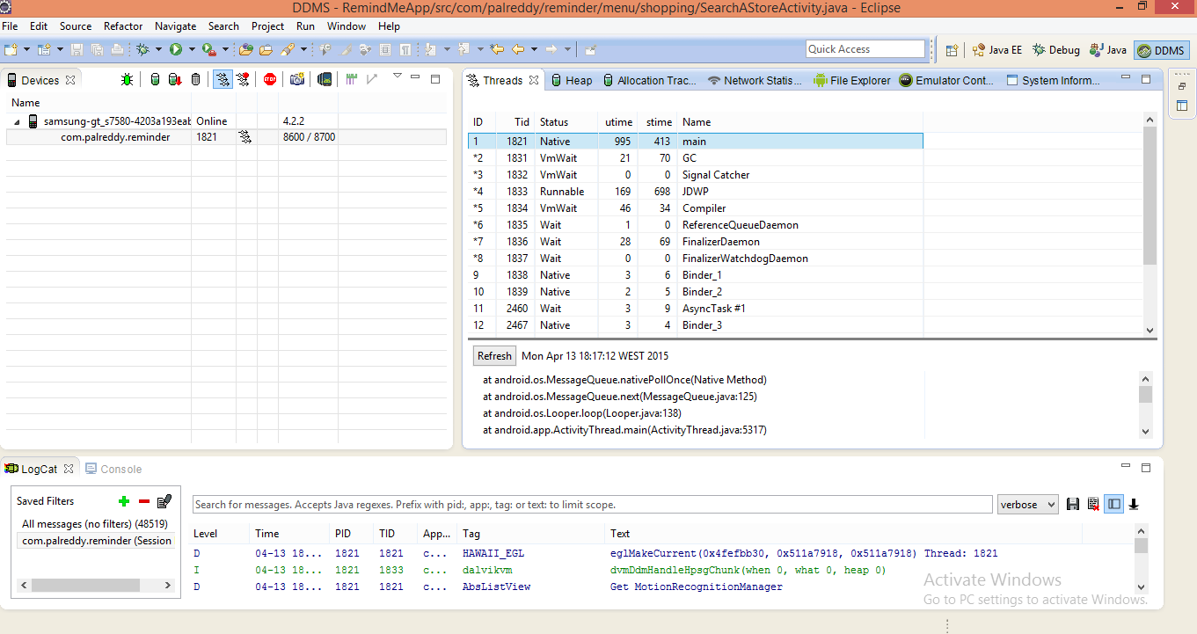

1. **Method Profiling**

In order to get more granular control over the collection of profiling data, we need to use startMethodTracing () and stopMethodTracing () methods.

On device tab by selecting startmethodtracing () and stopmethodtracing () we get the profiling information of the method.

Method profiling is used for tracking certain metrics for the method which are number of calls for the method, execution time of method.

In this case it shows all methods for the journey tab and their CPU time for execution.

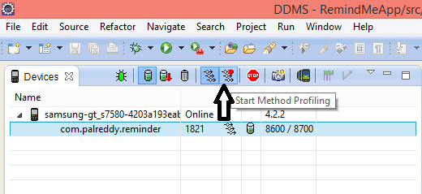

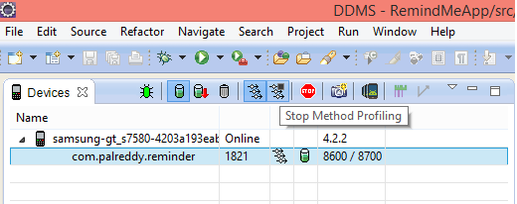

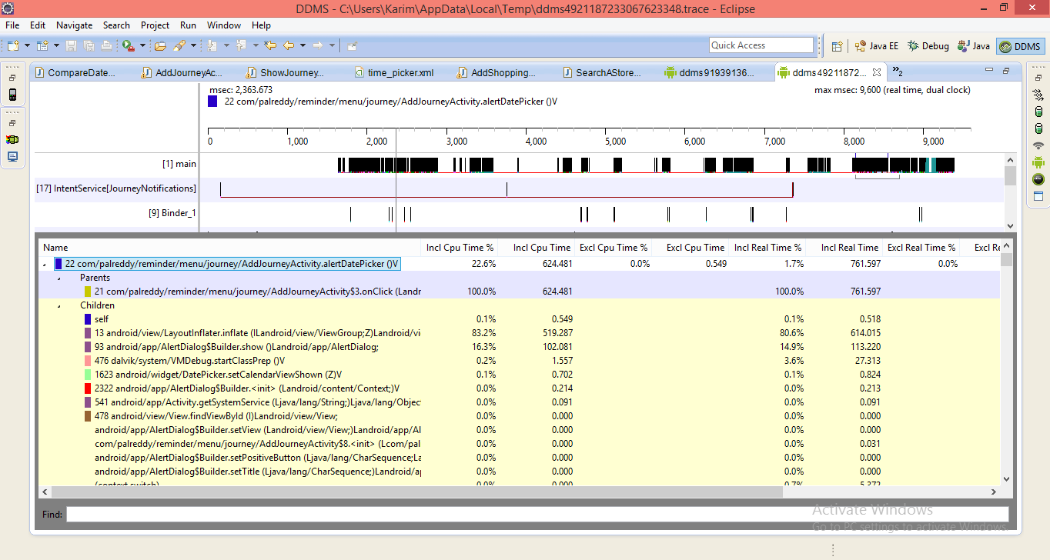

1. **Tracking memory allocations of objects**

This information is useful to trace the objects of which class and thread are being allocated in the memory which is useful for accessing the memory usage which can affect the application performance.

In this case for shopping tab the tracking of objects is performed and the allocations are examined between start and stop of the tracking button. On specific row selection it gives more detailed information about method and line number of the code allocated the object.

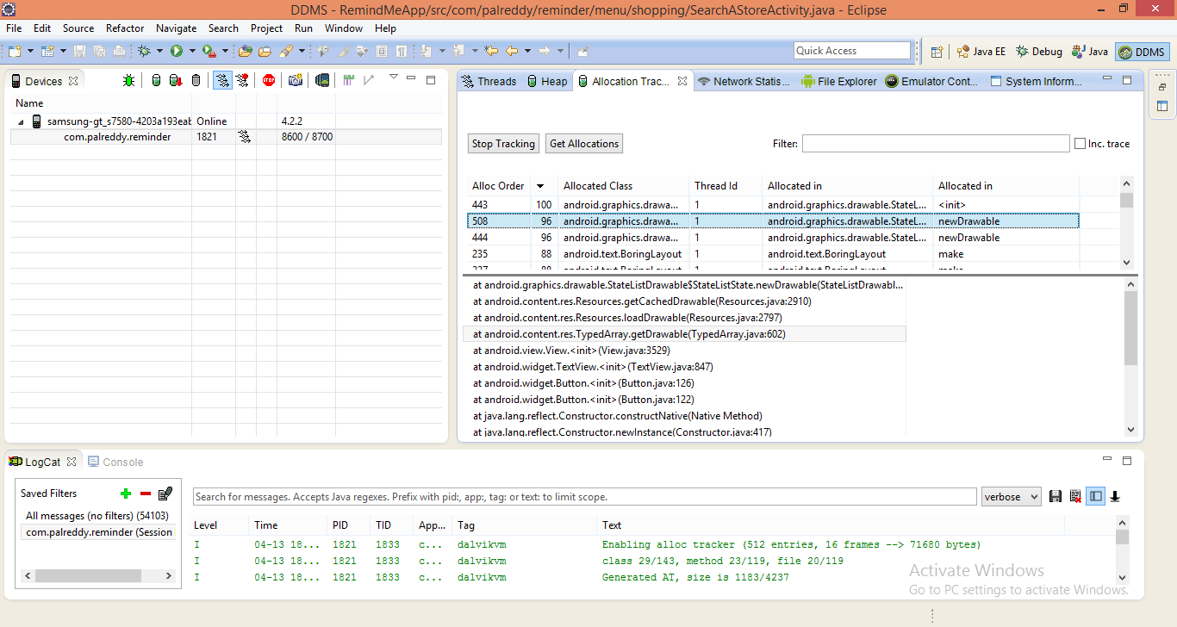

1. **Using LogCat**

LogCat is used to output the messages the same functionality done by the Log class. It also gives other message information like stack traces when exceptions are thrown. It is used to filter the messages output.

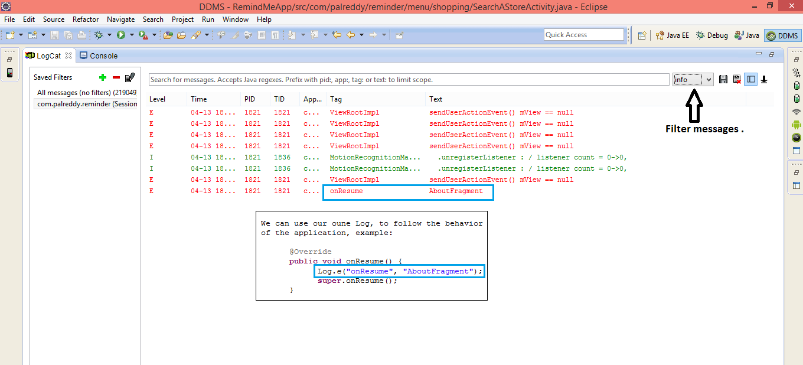

1. **Using the Network Traffic Tool**

This feature in DDMS includes a detailed network usage tab that makes it possible to track the application when it is making Network requests. This tool is used to monitor how and when the app transfers the data. It is also possible to distinguish different traffic types and by monitoring the frequency of the data transferred, we can identify the areas of app that can be made more battery efficient.

In this case for the journey tab list, shopping tab list and halt list network performance is calculated.

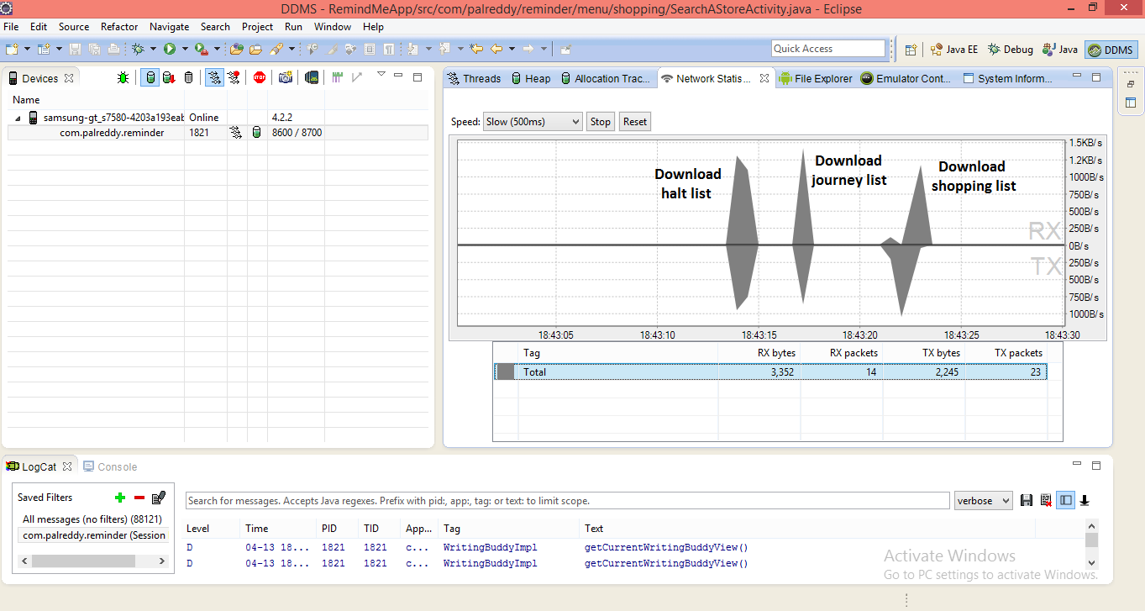

1. **Viewing Heap Usage for the process**

In order to see how much heap memory a process is using we need to do heap processing test. This information is necessary to track the memory usage during the execution of application.

In this case Heap usage is calculated for two processes and information obtained is about the objects and memory allocated. For a particular object type list on clicking it gives the bar graph information of number of objects allocated for that memory size. This gives the performance of the app in case of memory management.

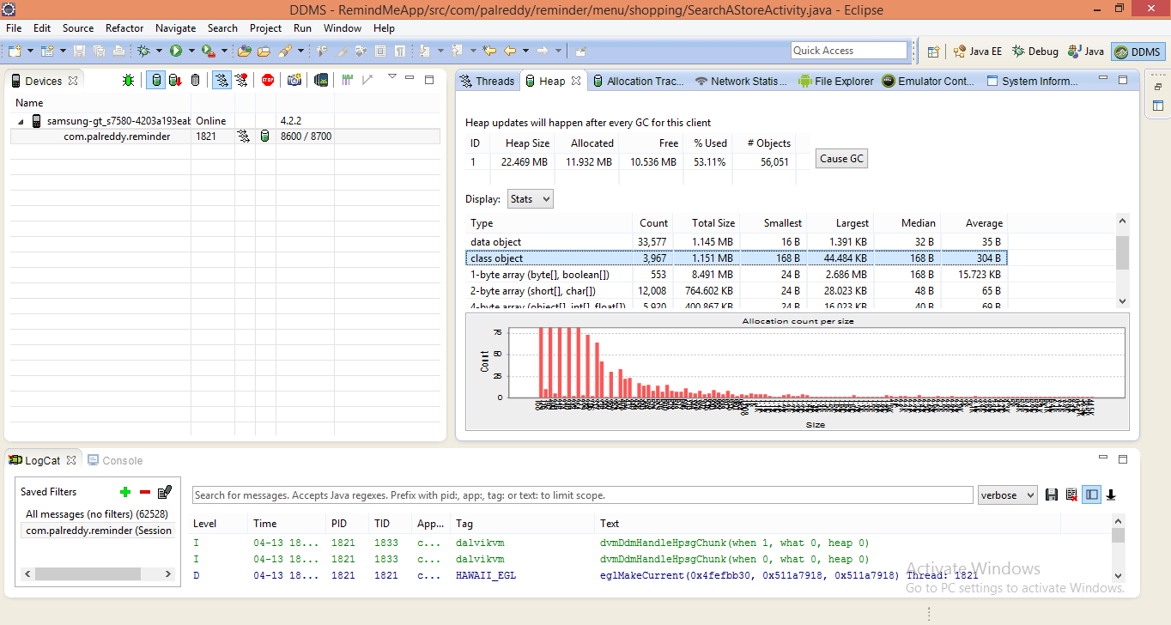

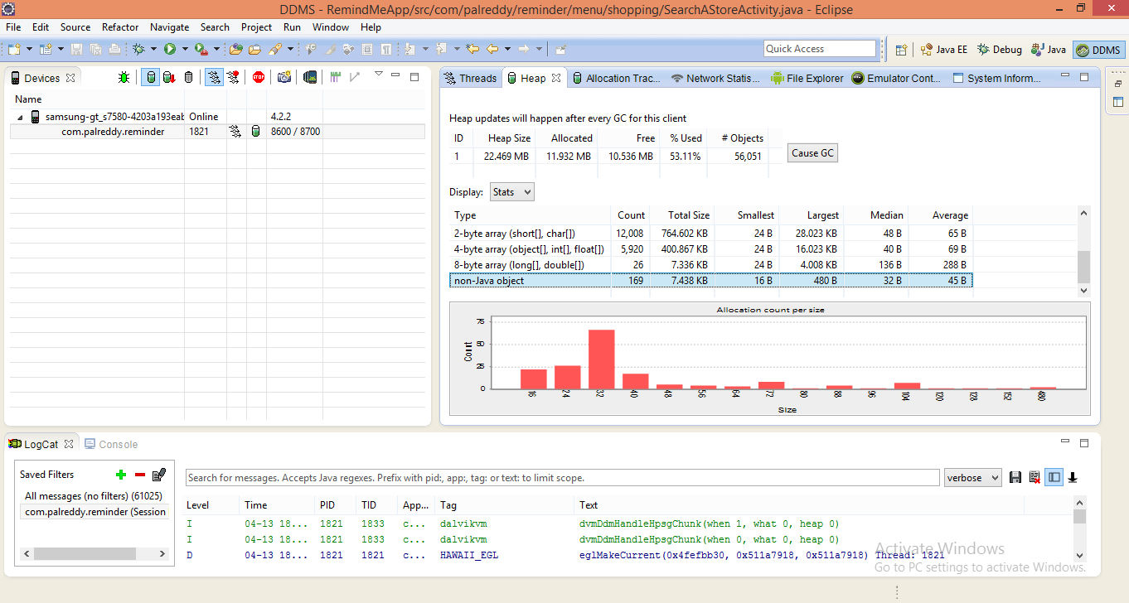

Scrumdo link:

<https://www.scrumdo.com/projects/project/remind-me/summary>

github link:

By

Mallika palreddy (37)

Prashanth venna (51)

Mehaboob gori (54)

Venakat purnesh gaddam(16)